Netflix  
Should you buy it?

_________________________________________________________________

By Mantas Vilius

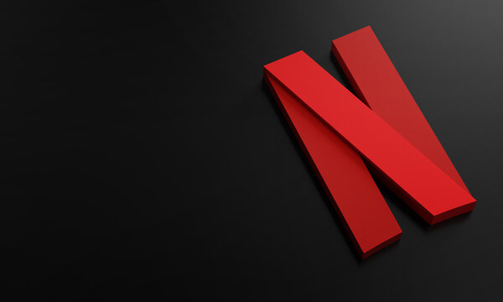

# Table of Contents

_________________________________________________________________

* Introduction
* Movies and Tv Shows
* Content Distribution
* Content Duration and Quality
* Conclusion

# INTRODUCTION

_________________________________________________________________

Netflix is a subscription-based streaming service that allows our members to watch TV shows and movies on an internet-connected device. Depending on your plan, you can also download TV shows and movies to your iOS, Android, or Windows device and watch without an internet connection.

If you are not sure that this product is for you, let me walk you through some data and insights to, maybe, help you to decide.

## Movies And Tv Shows

_________________________________________________________________

Main content Netflix provides is movies and shows. While most of the content is not built “in-house” and they bought rights to stream said content for a certain period of time or in perpetuity. They also have their own “Netflix Original” content.

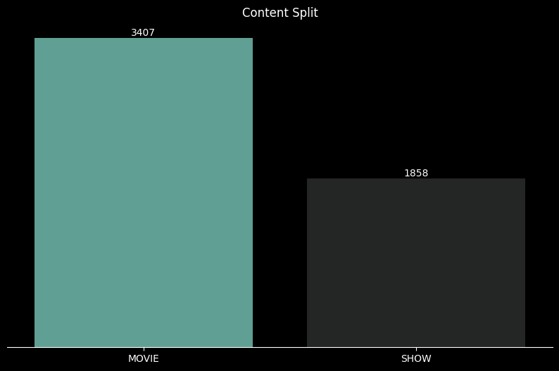

As you can see there is a big library, but keep in mind that as mentioned before some of the content might disappear down the road and Netflix being a live service product there will be new releases.

## 

## 

## Content Distribution

_________________________________________________________________

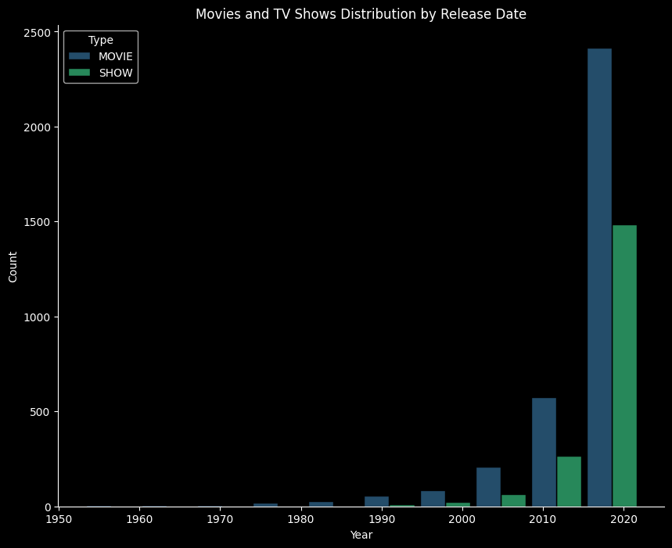

You can see that the main content was released from the late 90s to the present. If you are a fan of old-school movies/shows Netflix might feel barren to you, but keep in mind that that release year is for a movie/shows and Netflix can add content retroactively.

### Genre Distribution

If you are a person who chooses to consume content based on a single genre, meaning that you would, for example, watch a comedy in any setting (romantic, animation) there is a lot or, depending on the taste, not so much to choose from.  
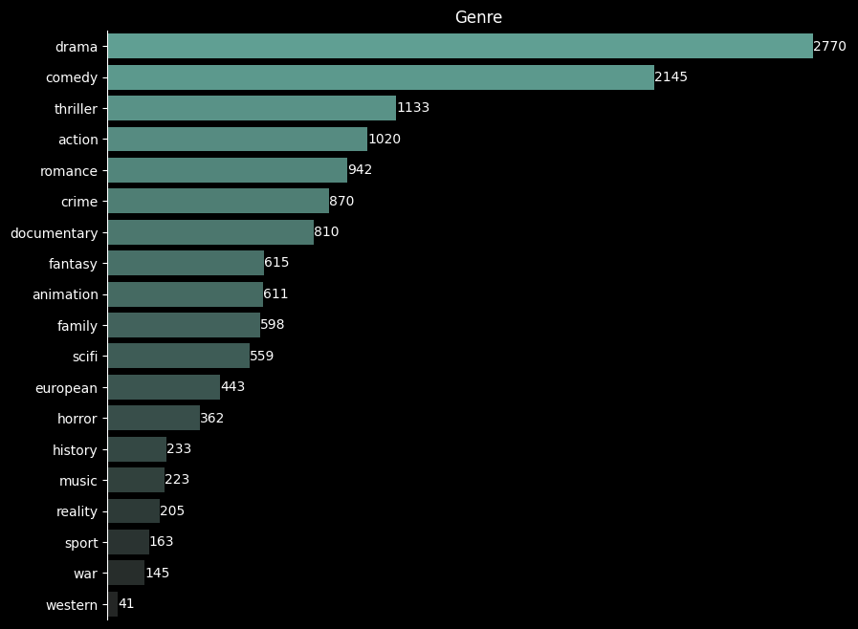

As mentioned earlier, old-school movies/shows are quite barren, but a lot of times content genres consist of multiple genres.

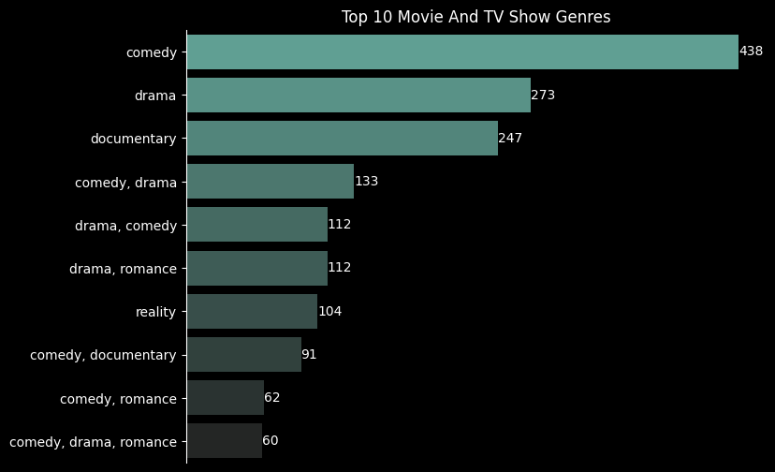

You can see that drama and comedy dominate across both types of content, but for more granularity and informed decision making let’s look at what type genres dominate movie and tv shows separately

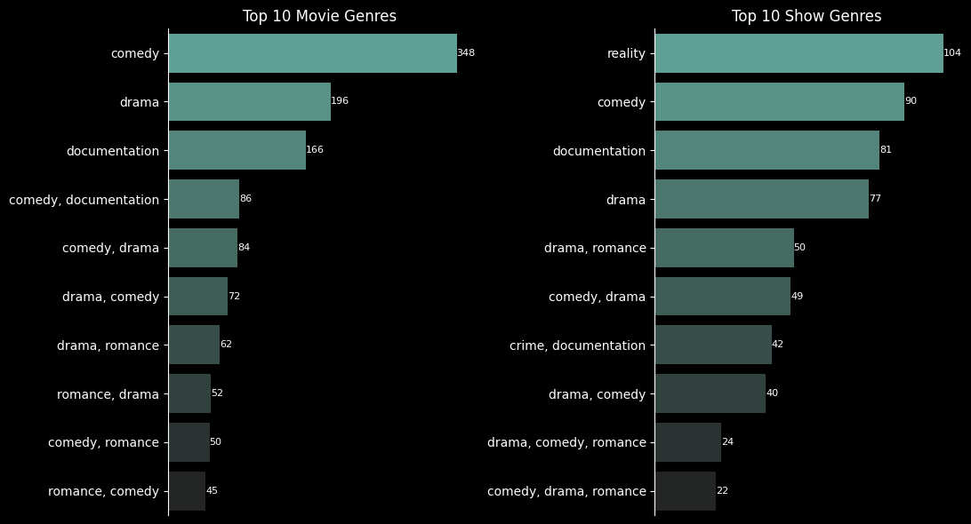

### Maturity Rating

Netflix offers a lot of types of packages, so if you considering buying a product for a whole family you should know what type of content is offered

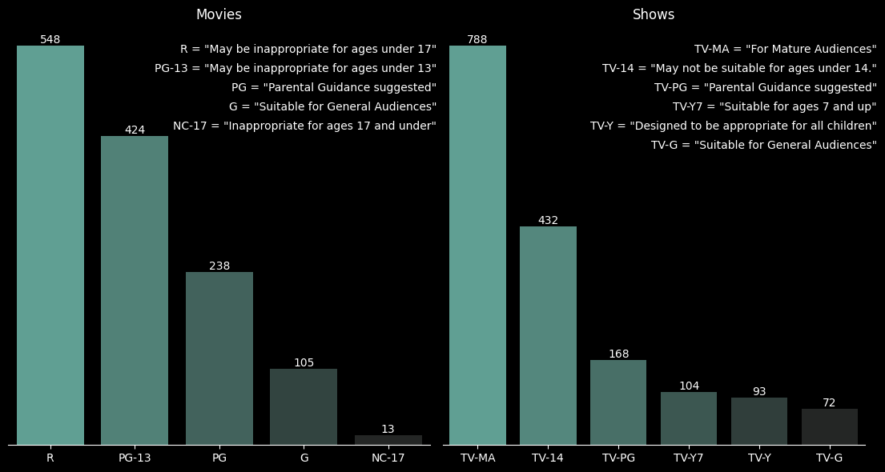

Movies and Tv Shows have a good amount of content designed for mature audiences and early teenagers, but also provides content for kids.

## 

## 

## Content Duration And Quality

_________________________________________________________________

### Duration

Now you might have a broad picture of what type of content Netflix provides in terms of genres and maturity rating, but it is also beneficial to know content duration for better free time planning.

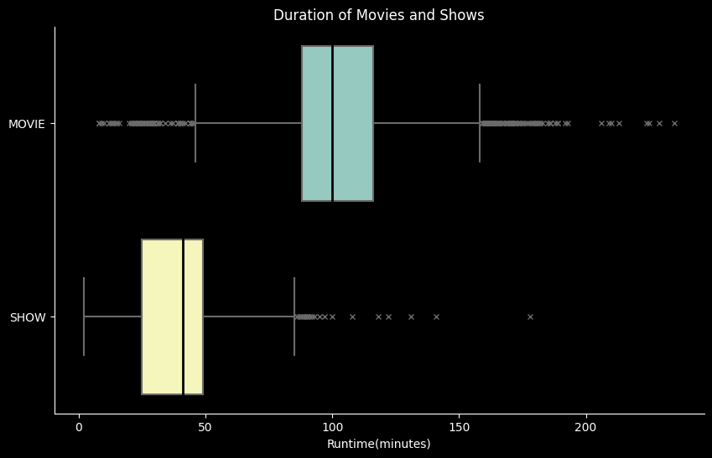

You can see that Movie content is lengthy with an average duration of around 100 minutes while Shows average is below 50 minutes.

### Quality

Planning time is a good approach but you want to spend quality time when you watch a movie or a TV show so which content offers more quality content?

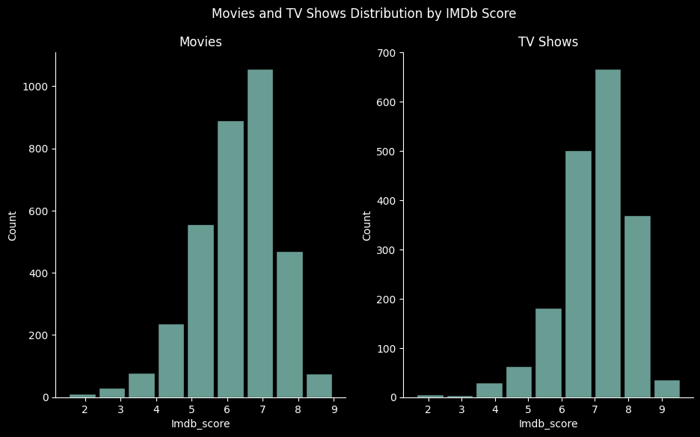

You can see that movies and tv shows have a lot of above-average quality content so whether you choose to watch lengthy or shorter content has little to no impact on the quality.

# Conclusion

_________________________________________________________________

Netflix offers a lot of content in terms of its genre and could be a good purchase for the whole family given that Netflix works across multiple devices. The quality of content is mostly above average and content is added constantly. What might turn you away is that Netflix lacks some old-school movies or shows.

But is it worth it? Well, given that pricing ranges a lot based on plan and/or region and it is a monthly fee, that's for you to decide and I hope this article helped with your decision.